## --------------------------------------------------------------------------------------------------------------------------------------

## CS5590 Mobile – Lab 5 –Report

## #26, Avni Mehta

## --------------------------------------------------------------------------------------------------------------------------------------

Objective:

1. To create an android application for a simple pedometer.
2. To create an android application for a face tracker that calculates the happiness and eye positions from the camera source.

Solution:

1. I have completed the Step Counter application as follows:

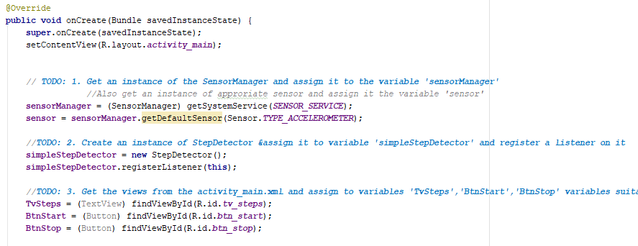

An incomplete application was provided with a list of TODOs.

* Several global variables have been declared (before onCreate).
* First, an instance of the SensorManager is generated using the method getSystemService(SENSOR_SERVICE)
* Then for that sensorManager, we get an Accelerometer sensor. Accelerometer is used to counting number of steps.
* For the next steps, I am getting views for Start button, Stop button and Steps Text View.

1. The Face Tracker application is basically Android Vision. Since this is not a part of the course curriculum, Karthik has confirmed that we can use the code from the [link](https://developers.google.com/vision/face-detection-concepts) he has provided.

The code is executing fine and I will explain the main points:

* The onCreate method of the main activity requests camera permission if not already provided, otherwise it creates and starts the camera.

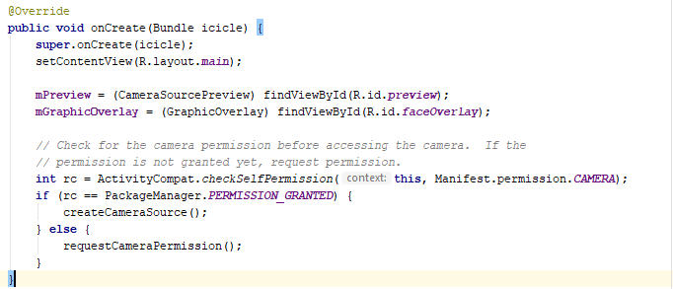

* Next, in the createCameraSource method, instance of FaceDetector is created and is initialized with options to detect all classifications of faces and creates and instance of CameraSource, initialized with options.

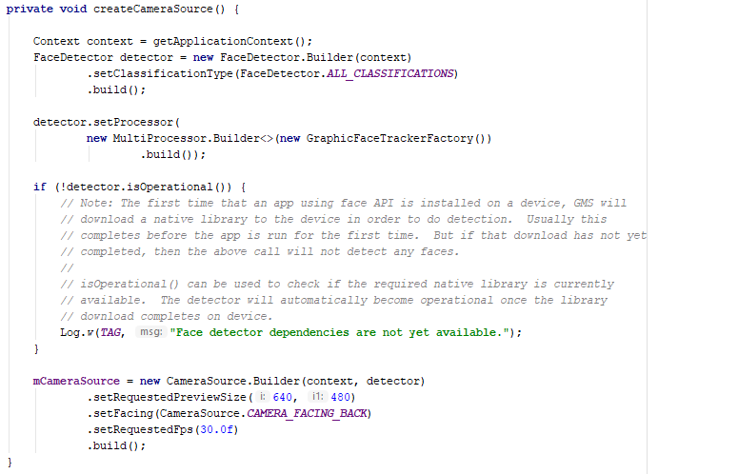

* The main logic to draw a box with happiness %, left eye % and right eye% is in FileGraphic.java
* The draw function is overridden, and a canvas is drawn with calculated offsets. The happiness%, right eye% and left eye% is calculated using face.getIsSmilingProbability(), face.getIsRightEyeOpenProbability() and face.getIsLeftEyeOpenProbability() respectively.

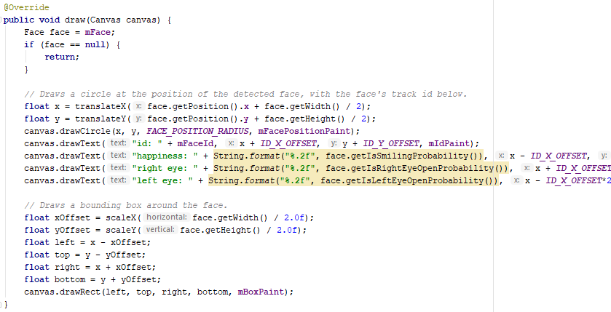

Output:

1. Step Counter

|  |  |
| --- | --- |
| User Interface | When Click on Start, and walk few steps |
| C:\Users\Avni Hardik Mehta.DESKTOP-RM37FMH\Documents\Avni\UMKC\SS 2018\CS5590 Web-Mobile\Mobile\Lab\Lab-5\Documentation\t1o1.png | C:\Users\Avni Hardik Mehta.DESKTOP-RM37FMH\Documents\Avni\UMKC\SS 2018\CS5590 Web-Mobile\Mobile\Lab\Lab-5\Documentation\t1o2.png |

|  |  |
| --- | --- |
| As we walk, the count increases | On clicking Stop, the number of steps doesn’t increase when we walk |
| C:\Users\Avni Hardik Mehta.DESKTOP-RM37FMH\Documents\Avni\UMKC\SS 2018\CS5590 Web-Mobile\Mobile\Lab\Lab-5\Documentation\t1o3.png | C:\Users\Avni Hardik Mehta.DESKTOP-RM37FMH\Documents\Avni\UMKC\SS 2018\CS5590 Web-Mobile\Mobile\Lab\Lab-5\Documentation\t1o4.png |

1. Face Tracker

|  |  |
| --- | --- |
| **Happy Person, Open Eyes** | **Happy Person, Half-closed eyes** |
| Happiness = 98%, L. Eye = 100%, R. Eye = 99% | Happiness = 95%, L. Eye = 19%, R. Eye = 29% |
| C:\Users\Avni Hardik Mehta.DESKTOP-RM37FMH\Documents\Avni\UMKC\SS 2018\CS5590 Web-Mobile\Mobile\Lab\Lab-5\Documentation\t2o1.png | C:\Users\Avni Hardik Mehta.DESKTOP-RM37FMH\Documents\Avni\UMKC\SS 2018\CS5590 Web-Mobile\Mobile\Lab\Lab-5\Documentation\t2o2.png |

|  |
| --- |
| **Unhappy Person, Open Eyes** |
| Happiness = 28%, L. Eye = 99%, R. Eye = 86% |
| C:\Users\Avni Hardik Mehta.DESKTOP-RM37FMH\Documents\Avni\UMKC\SS 2018\CS5590 Web-Mobile\Mobile\Lab\Lab-5\Documentation\t2o3.png |

**Code:**

The [source code](https://github.com/AvniM/Web-Mobile/tree/master/Lab/Lab-5/Source) is uploaded to Github.